NACD Cave Diving Safety Notice
Do You Need to Read This?
Are you planning a CAVE DIVE but you are . . .
Neither formally trained nor certified in Cavern or Cave Diving?
Making one of your initial dives into a spring, cave, or blue hole?
Not using at least two dependable underwater lights, a guideline on a reel, a submersible pressure gauge, and an additional second stage?
If your answer was "yes" to any of these questions, then you are typical of most cave-diving fatalities. Since 1960, more than 431 divers fitting the above description -- that is, untrained, inexperienced, and improperly equipped -- have died in cave diving accidents in Florida, Mexico and the Caribbean.
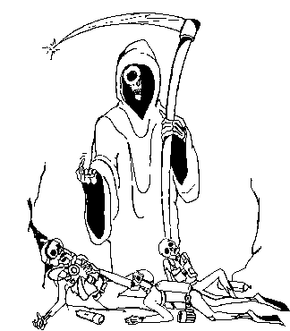
This web page has been prepared as a public service by the Cave Diving Section of the National Speleological Society (NSS-CDS) to help you avoid those mistakes that have frequently contributed to the cave diving deaths of others.
NO AMOUNT OF PREVIOUS OPENWATER DIVING EXPERIENCE OR TRAINING CAN ADEQUATELY PREPARE YOU FOR CAVE DIVING.
Regardless of their prior openwater experience, most cave diving accident fatalities were untrained in cave-diving procedures, inadequately equipped for the planned dive, and/or making one of their initial cave dives. Many were extremely experienced in other types of diving. No less than 19 were FULLY CERTIFIED OPEN WATER SCUBA INSTRUCTORS -- but without any training in the specialized area of cave diving.
Interviews with the surviving dive buddies suggest that frequently the divers originally planned only to take a quick peek "just inside the cave entrance" -- that they weren't really planning a full-fledged "cave dive." But in many instances the divers got into trouble immediately -- "just inside the cave entrance!" In other cases, they decided to continue further into the cave despite their plan and became hopelessly lost. When their bodies were recovered later, there was every evidence that their pre-death experience was panic-stricken, horrifying, and filled with thoughts of their own stupidity, their families, their dead buddies and their own lost life.
Why did these divers drown? The answer lies in part with their ignorance of the unique HAZARDS found in caves, and their failure to prepare for, recognize and deal with these hazards appropriately.
For example, when cave diving, the cave CEILING restricts direct access to the surface, making you completely dependent upon your equipment and its proper function. Should an emergency such as air failure occur, you cannot make a free ascent to the surface as you would when diving in open water you must first swim out of the cave the way you came in -- out, and then up. Yet many divers, unaware of this consequence of having a ceiling, fail to plan for such an emergency.
In addition, many divers also fail to realize that because of the ceiling, normal openwater rules for air reserves are completely inadequate in a cave scenario -- that it will usually take at least as much air to exit the cave as it took to enter, since the divers must swim back out of the cave the same way they went in. Any kind of time-consuming problem or emergency, or the catastrophic loss of an air supply by one of the dive team members, will require MUCH MORE air -- even two or three times more air. Other divers depend only on their dive light and memory of the cave to navigate the cave's MAZE-LIKE PASSAGEWAYS. But should their dive light(s) fail (which is very common, especially when a light inadvertently bumps into the walls or floor of a cave) or memory fail, there are only two things that will help them exit safely: having learned special emergency procedures (reducing the panic factor), and having a safety guideline connected with the surface.
Another unexpected hazard is SILT, or loose sediment that is found on all underwater cave floors and walls. Some of the most popular cavern and cave diving locations feature entrances which are nearly silt free; yet just a few feet beyond the entrance, the floors are covered with deep, potentially treacherous silt.
Normal open water swimming techniques can easily stir up silt, reducing visibility from a hundred feet to near zero with only a few strokes of a fin blade. Imagine swimming forward into clear, beautiful water, only to turn around and see a wall of impenetrable silt when you attempt to exit. Again, only having a continuous guideline to the surface and having practiced and learned emergency procedures will insure a safe exit.
The most important single piece of equipment for cave diving is also the most hazardous to use. Many openwater divers have thought that if they carried a guideline, they could explore a cave safely. Nothing could be further from the truth, and there have been many deaths as a result of these divers getting tangled in their own guideline. Only formal cavern and cave diving courses can teach you the safe and effective procedures for deploying, securing, and following a guideline. Many hours of classroom, field, and underwater training are devoted to guideline usage.
Yet despite these potential hazards, thousands of cave dives are made each year in complete safety by those who have learned to cave dive properly. They are divers much like you, differing only in that they have completed the specialized training and have learned about the quiet, strange and beautiful environment of underwater caves, and respect the caves' unique hazards.
If you see this sign...
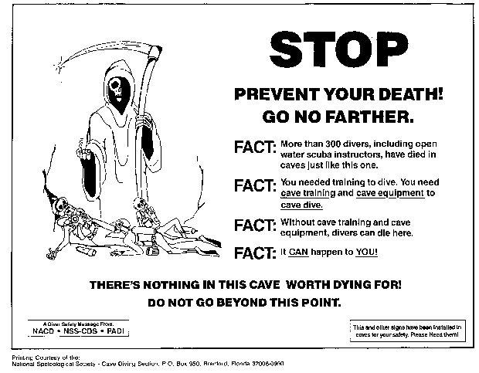
and are not trained as a cave diver, heed it's warning!
Cave Diving Training
The best way to become a safe cave diver is to first become a certified scuba diver and to accumulate open water diving experience. Then seek out a cavern and cave diving course. Do not attempt to go cave diving without first acquiring cave diving training. Remember, the vast majority of cave diving fatalities were untrained in cavern or cave diving, and were making one of their first cave dives. Remember also that reading a book about cave diving is no substitute for the in-water training and skills you will acquire under the expert guidance of an experienced, certified cave diving instructor.
A highly experienced and seasoned cave diver once said that to go from visiting an open water reef to exploring an underwater cave -- while causing the minimum damage to both the diver and the fragile cave environment -- requires a quantum leap in experience and expertise. The NSS-CDS and the NACD have developed the following courses designed to provide you with the skills necessary to begin to cave or cavern dive safely.

Cavern Diver
Many of the most interesting features of the cave can be found within the "cavern," that area of the cave which receives surface light. The objective of the course is to introduce the student to the cave environment using virtually all regular open water equipment. Lasting a single weekend, the course covers the cavern environment, techniques, and philosophy. It also includes in-water practice of safety and emergency procedures, and three cavern diving sessions.

Introduction to Cave Diving
This course is for those cavern divers who wish to explore beyond the cavern zone, but are not ready to undertake a full cave diving course. It lasts one weekend and emphasizes the skills and equipment necessary to dive that portion of a cave accessible on a single-tank air supply.

Cave Diver Courses: Apprentice Cave Diver, Full Cave Diver
A two-stage program encompassing approximately 4 days or more of highly specialized, private instruction in which the student is taught the fundamental and more advanced aspects of cave diving, including complex dive planning, advanced guideline protocols, surveying and cartography, and stage diving (diving beyond the normal limits of a dual-cylinder air supply). Completion of both stages of the Cave Diver program is highly recommended before the student attempts any unsupervised complex cave dives.

Conservation
You can choose between risking your life and cave diving safely, but the cave has no choice -- it's there, and it and the surrounding property are vulnerable to vandalism. Caves have unique scientific, recreational and aesthetic values that should be preserved for future generations to study and enjoy. NSS-CDS members must pledge to do nothing that will deface, mar, or otherwise spoil the natural beauty and life forms in caves. The NSS-CDS motto is:
Take nothing but pictures . . .
Leave nothing but bubbles . . .
Kill nothing but time.
As divers are conspicuous features around the springs and sinkholes of Florida, Mexico and the Bahamas, much of the litter there is attributed to them. Even though much of this litter arises from casual visitors and swimmers, the NSS-CDS asks that each time you dive, you take the time to pick up and properly dispose of a few pieces. In this way we can each do our part to keep these areas beautiful, to continue our welcome at them, and hopefully to stimulate others to better conservation habits.
Additional information on cave diving safety, books, instructors in your area, and newsletters may be obtained by writing to the:
NSS Cave Diving Section National Association for Cave Diving
2109 W US 90, Suite 170-317 PO Box 14492
Lake City, FL 32055 Gainesville FL 32604

